A REPORT

ON
AI GPU Summer Internship Program

Submitted by

Ms. Sneha S - 20241CSE0846

Under the guidance of,
Mr. Sakthi S
Ms. Shaik Salma Begum

in partial fulfillment for the award of the degree of
BACHELOR OF TECHNOLOGY

IN

COMPUTER SCIENCE AND ENGINEERING

AT



PRESIDENCY UNIVERSITY
BENGALURU
AUGUST 2026

PRESIDENCY UNIVERSITY

PRESIDENCY SCHOOL OF COMPUTER SCIENCE AND ENGINEERING


CERTIFICATE

This is to certify that the report of CSE7000 – Internship on “AI GPU Summer Internship Program” being submitted by “SNEHA S” bearing roll number “20241CSE0846” in partial fulfillment of the requirement for the award of the degree of Bachelor of Technology in Computer Science and Engineering is a bonafide work carried out under our supervision.

Mr. Sakthi S  Assistant Professor  PSCS  Presidency University | Ms. Shaik Salma Begum  Assistant Professor  PSCS  Presidency University | Dr. Balakrishnan R  Internship Coordinator  PSCS  Presidency University

Dr. Bhuvaneshwari Patil  School level coordinator  PSCS  Presidency University | Dr. Asif Mohamed  HoD  PSCS  Presidency University | Dr. Duraipandian N  Dean – PSCS  Presidency University

PRESIDENCY UNIVERSITY

PRESIDENCY SCHOOL OF COMPUTER SCIENCE AND ENGINEERING

DECLARATION

I hereby declare that the work, which is being presented in the report entitled “AI GPU Summer Internship Program” in partial fulfillment for the award of Degree of Bachelor of Technology in Computer Science and Engineering is a record of my own investigations carried under the guidance of Mr. Sakthi S, Assistant Professor and Ms. Shaik Salma Begum, Assistant Professor, Presidency School of Computer Science and Engineering, Presidency University, Bengaluru.

I have not submitted the matter presented in this report anywhere for the award of any other Degree.

Sneha S,
20241CSE0846

ACKNOWLEDGEMENT

First of all, I indebted to the GOD ALMIGHTY for giving me an opportunity to excel in our efforts to complete this internship on time.
I express sincere thanks to our respected Dean Dr. Duraipandian N, Presidency School of Computer Science and Engineering,Presidency University for getting us permission to undergo the internship.
I express heartfelt gratitude to our beloved Dr. Asif Mohammad, Head of the Department, Presidency School of Computer Science and Engineering, Presidency University, for rendering timely help in completing this internship successfully.
I am greatly indebted to my reviewers Mr. Sakthi S, Assistant Professor and Ms. Shaik Salma Begum, Assistant Professor, Presidency School of Computer Science and Engineering, Presidency University for their inspirational guidance, and valuable suggestions and for providing a chance to express technical capabilities in every respect for the completion of the internship work.
I would like to convey gratitude and heartfelt thanks to the Internship Coordinator Dr. Bhuvaneshwari Patil and Program Internship Coordinator Dr. Balakrishnan R. I also thank my family and friends for the strong support and inspiration they have provided us in bringing out this internship.

Sneha S (20241CSE0846)

ABSTRACT

The AI Student Assistant Learning project is an intelligent web-based learning platform designed to enhance the educational experience by providing students with personalized, interactive, and efficient study support. The system leverages Artificial Intelligence (AI) to simplify the learning process by converting uploaded study materials, such as PDF documents, into engaging learning resources. It helps students understand concepts more effectively while reducing the time required for manual note-taking and revision.
The application allows students to upload educational PDFs, after which the AI analyzes the content and generates concise summaries, key points, flashcards, quizzes, and practice questions. The platform also provides instant feedback by explaining the correct answers whenever a student selects an incorrect option, enabling better understanding and concept reinforcement. Additionally, the system includes a leaderboard that motivates learners through healthy competition and encourages continuous improvement in their academic performance.
The project is developed using modern web technologies and AI-based Natural Language Processing (NLP) techniques to extract meaningful information from study materials. The platform focuses on improving learning efficiency by offering personalized revision tools that help students retain information more effectively. Its user-friendly interface ensures easy navigation, making it accessible to students with varying levels of technical knowledge.
The primary objective of this project is to create an AI-powered learning companion that supports self-paced education, improves knowledge retention, and enhances student engagement. By integrating intelligent content analysis with interactive learning features, the system provides a comprehensive digital learning environment suitable for schools, colleges, and self-learners. It minimizes the challenges associated with traditional learning methods by delivering quick access to essential information and adaptive study resources.
Overall, the AI Student Assistant Learning platform demonstrates how Artificial Intelligence can transform conventional education into a smarter, more personalized, and interactive learning experience. The project contributes to modern digital education by improving academic productivity, encouraging active learning, and supporting students in achieving better educational outcomes through intelligent and automated learning assistance.

INTRODUCTION

The rapid advancement of Artificial Intelligence (AI) has significantly transformed various sectors, including education. Modern learning environments require intelligent systems that can assist students in understanding concepts more effectively, reducing manual effort, and providing personalized learning experiences. However, students often spend considerable time creating notes, flashcards, quizzes, and revision materials from textbooks and lecture notes. Traditional learning methods also lack adaptive feedback mechanisms that help students identify weak areas and improve their overall academic performance. As a result, there is a growing need for AI-powered educational platforms that can automate these tasks while enhancing learning efficiency.
The AI Student Learning Assistant is an AI-powered web application designed to transform study materials into interactive learning resources. The application accepts multiple file formats such as PDF, DOCX, TXT, Markdown, and image files, extracts the textual content, and processes it using advanced Large Language Models (LLMs) through the Groq API. Based on the uploaded content, the system automatically generates detailed summaries, short summaries, revision notes, one-page quick notes, conceptual flashcards, and adaptive quizzes. This automation significantly reduces the time students spend preparing study materials while improving the quality of learning resources.
The application goes beyond content generation by providing intelligent performance analysis. After completing AI-generated quizzes, students receive detailed feedback that includes weak topic identification, exam readiness scores, personalized study plans, and AI tutor explanations for incorrect answers. These features help learners focus on areas requiring improvement and enable a personalized learning experience based on individual performance rather than a one-size-fits-all approach.
In addition to learning assistance, the system provides several advanced academic support features, including a Career Navigator, GPA Predictor, Research Lab, Achievement Certificates, Leaderboard, and Spaced Repetition. These modules encourage continuous learning, improve long-term knowledge retention, and help students monitor their academic progress through an interactive dashboard. The integrated analytics enable students to visualize their performance and make informed decisions about their study strategies.
The application is developed using modern Full-Stack Web Development technologies. The backend is implemented using Python and the Flask framework, while the frontend is built using HTML5, CSS3, JavaScript, and Jinja2. AI capabilities are powered by Groq LLMA models, including LLMA 3.3 70B, LLMA 3.1 8B, and LLMA 4 Scout Vision for intelligent text generation and OCR-based image processing. The system supports both SQLite and PostgreSQL databases, providing flexibility for local development as well as production deployment.
Overall, the AI Student Learning Assistant demonstrates how Artificial Intelligence, Natural Language Processing, and Full-Stack Web Development can be integrated to create an intelligent educational platform. The project simplifies the learning process, improves academic performance through personalized recommendations, and provides students with an efficient and engaging digital learning environment. It represents a practical application of Generative AI in education and highlights the potential of AI-powered systems to support modern teaching and learning methodologies.

OBJECTIVE

The primary objective of this internship project is to develop an AI-powered Student Learning Assistant that transforms study materials into interactive learning resources using Artificial Intelligence. The system aims to improve learning efficiency by automating study material generation, assessing student performance, and providing personalized academic support.
Specific Objectives
- To develop an AI-based application that accepts study materials in multiple formats such as PDF, DOCX, TXT, Markdown, and Images.
- To automatically generate summaries, revision notes, flashcards, and quizzes using Large Language Models (LLMs).
- To create adaptive quizzes that evaluate students' understanding with configurable difficulty levels.
- To analyse quiz performance and identify weak topics for personalized learning.
- To generate personalized study plans, AI tutor feedback, and exam readiness scores based on quiz performance.
- To provide additional learning support through features such as Career Navigator, GPA Predictor, Research Lab, and Spaced Repetition.
- To store learning materials, quiz history, and performance analytics in a secure database for future reference.
- To develop a responsive and user-friendly web application using modern Full-Stack technologies.
- To improve learning efficiency by reducing manual effort and providing intelligent, personalized academic assistance.

WORK PROGRESS

Day 1 – GPU Environment Setup
The internship began with understanding the GPU-enabled working environment. I learned about pod creation, resource allocation, and launching Jupyter Lab with GPU support. I also understood the importance of proper environment configuration for AI development.

Day 2 – Artificial Intelligence and Machine Learning
I studied the fundamentals of Artificial Intelligence and Machine Learning. The session covered AI concepts, machine learning types, data, features, models, training, testing, and prediction. I also learned about supervised and unsupervised learning.

Day 3 – Neural Networks
I learned the fundamentals of neural networks, including neurons, input, hidden and output layers, weights, biases, and activation functions. I also understood how neural networks process data and identify patterns.

Day 4 – Deep Learning
The session focused on Deep Learning and multi-layer neural network architectures. I studied feature extraction, deep learning applications, dataset requirements, and the computational resources required for training deep learning models.

Day 5 – Full-Stack Development
I explored the Antigravity tool and revised full-stack development concepts. I learned the roles of frontend, backend, and databases and understood how these components communicate to form a complete software application.

Day 6 – Transformer Architecture
I studied Transformer architecture and attention mechanisms, including encoder-decoder structures and multi-head attention. I also learned how transformers process contextual information and their applications in modern Natural Language Processing systems.

Day 7 – Large Language Models
The session focused on Large Language Models and efficient fine-tuning techniques. I learned about LoRA, PEFT, transfer learning, model customization, and optimization methods for specialized AI applications.

Day 8 – Generative AI
I studied Generative AI and image generation using Stable Diffusion XL. I explored text-to-image generation, prompt engineering, and the effect of different prompts and model configurations on generated outputs.

Day 9 – GPU Optimization
I learned GPU optimization techniques for improving AI model performance. The topics included mixed precision training, memory optimization, Flash Attention, tensor parallelism, and efficient GPU resource utilization.

Day 10 – Capstone Project and Evaluation
The internship concluded with the capstone project presentation and technical review. I presented the project implementation, discussed challenges and future improvements, received feedback from mentors .

RESULTS

The AI Student Learning Assistant was successfully designed, developed, and tested as an AI-powered educational web application. The system efficiently transforms study materials into interactive learning resources by leveraging Artificial Intelligence and Large Language Models. It accepts multiple document formats, including PDF, DOCX, TXT, Markdown, and Images, and automatically generates high-quality learning content.
The developed application successfully generated Detailed Summaries, Short Summaries, Revision Notes, One-Page Quick Notes, Flashcards, and Adaptive Quizzes from uploaded study materials. The AI-generated content reduced the manual effort required for preparing study resources while improving learning efficiency.
The quiz module effectively evaluated student performance by identifying weak topics, calculating exam readiness scores, and generating personalized study plans along with AI tutor feedback for incorrect answers. These features enabled students to understand their strengths and focus on areas requiring improvement.
The application also integrated advanced learning modules such as Career Navigator, GPA Predictor, Research Lab, Leaderboard, Achievement Certificates, and Spaced Repetition, providing students with a comprehensive and personalized learning experience. An interactive dashboard allowed users to monitor learning progress, review analytics, and access all generated study resources from a centralized platform.
Overall, the project successfully achieved its objectives by integrating Artificial Intelligence with Full-Stack Web Development to create an intelligent educational platform. The developed system demonstrates how Generative AI can simplify learning, enhance academic performance, and provide personalized educational support through automated content generation and performance analytics.

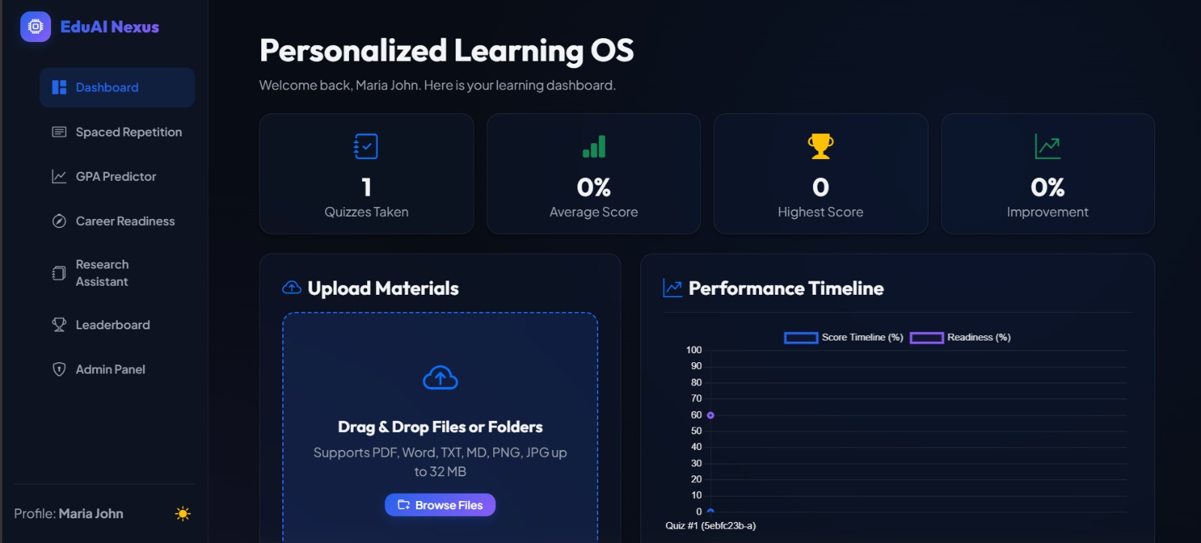
Fig. 1.1: Student Dashboard and Performance Overview

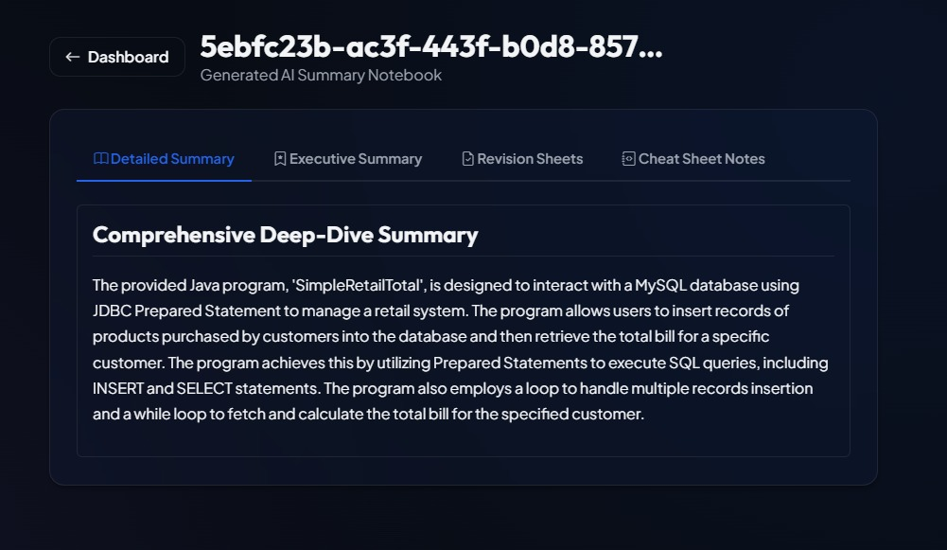
Fig. 1.2: AI-Generated Study Summary

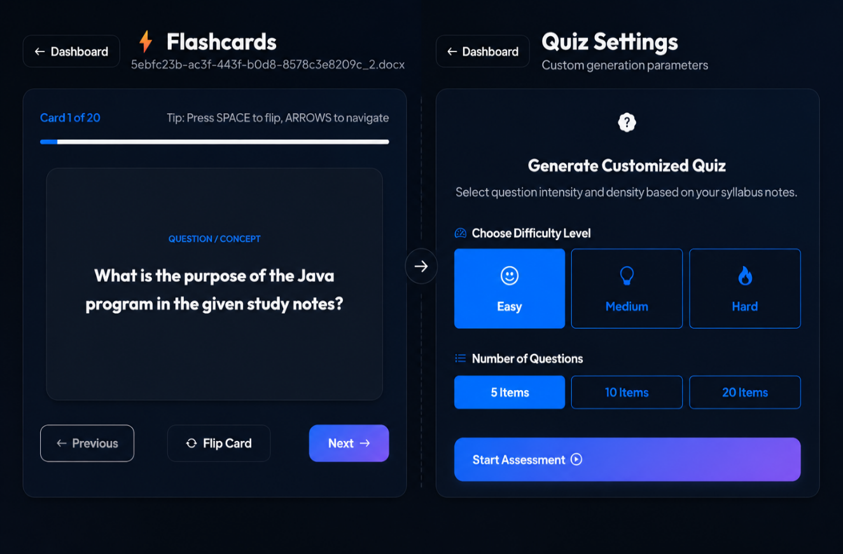
Fig. 1.3: Flashcards and Quiz Configuration

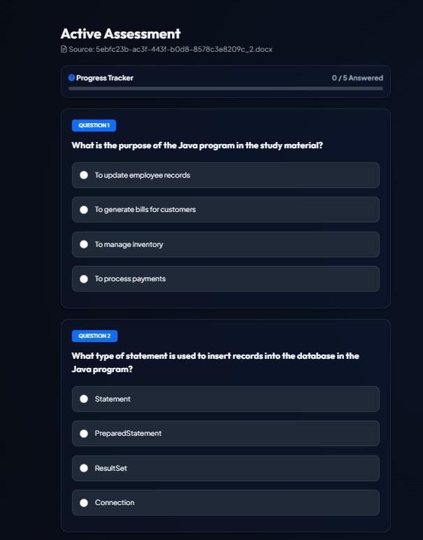
Fig. 1.4: AI-Generated Quiz Assessment

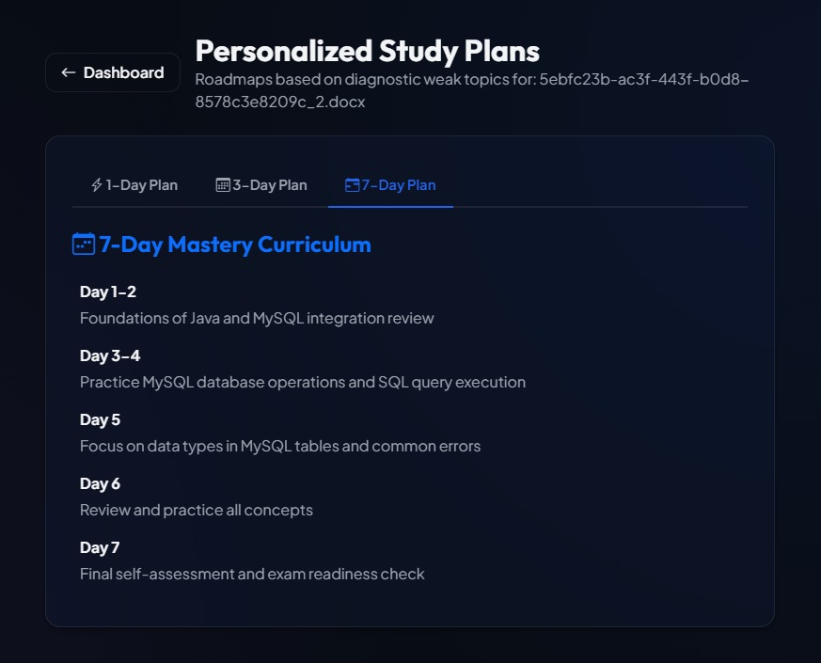
Fig. 1.5: Personalized Study Plan
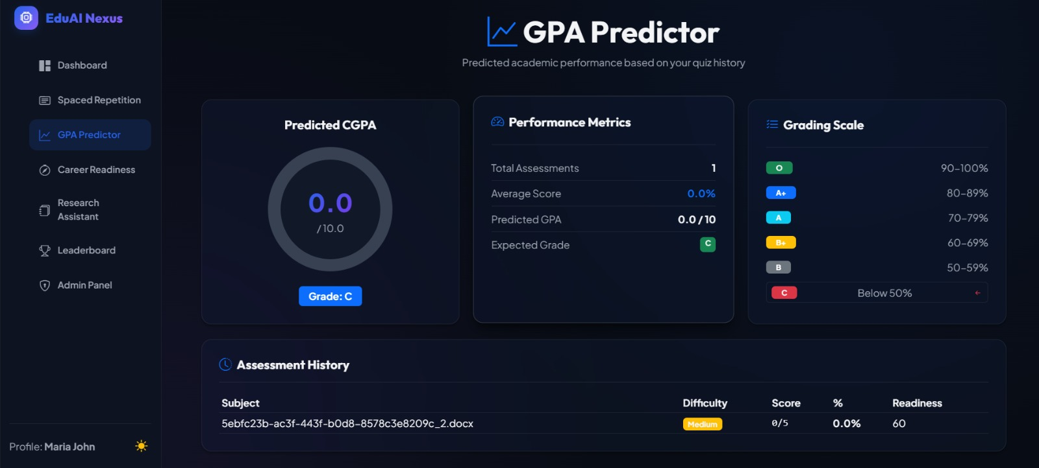 Fig. 1.6: GPA Prediction Dashboard

CONCLUSION

The AI Student Learning Assistant was successfully designed and developed as an intelligent educational platform that leverages Artificial Intelligence to simplify and enhance the learning process. The application transforms study materials into interactive learning resources by automatically generating summaries, flashcards, revision notes, quizzes, and personalized study plans. It also provides AI tutor feedback, performance analytics, and exam readiness assessment, enabling students to learn more effectively and improve their academic performance.
The project successfully integrates Artificial Intelligence, Natural Language Processing, and Full-Stack Web Development using modern technologies such as Python, Flask, Groq LLaMA models, HTML, CSS, JavaScript, and SQLite/PostgreSQL. The combination of these technologies resulted in a scalable, user-friendly, and efficient application capable of supporting personalized learning experiences.
Throughout the internship, I gained valuable practical experience in Artificial Intelligence, Generative AI, Large Language Models (LLMs), Full-Stack Web Development, REST API development, database management, and software development practices. Developing this project enhanced my technical knowledge, problem-solving skills, and understanding of building end-to-end AI applications for real-world educational use cases.
Overall, the project achieved its objectives by providing an intelligent, AI-driven learning platform that reduces manual effort, supports personalized education, and promotes effective learning. It demonstrates the practical application of Generative AI in the education domain and highlights its potential to improve academic outcomes through intelligent automation and personalized learning support.

REFERENCE

[1] Flask, “Flask Documentation,” official guide for web application development. Available: https://flask.palletsprojects.com/
[2] Groq Inc., “Groq API Documentation,” guide for AI model API integration. Available: https://console.groq.com/docs
[3] Meta AI, “LLaMA Models,” documentation for Large Language Models. Available: https://ai.meta.com/llama/
[4] PostgreSQL Global Development Group, “PostgreSQL Documentation,” guide for database management. Available: https://www.postgresql.org/docs/
[5] PyMuPDF, “PyMuPDF Documentation,” guide for PDF text extraction and processing. Available: https://pymupdf.readthedocs.io/
[6] PyPDF, “PyPDF Documentation,” guide for reading and extracting PDF content. Available: https://pypdf.readthedocs.io/
[7] Python Software Foundation, “Python 3 Documentation,” reference for Python programming. Available: https://docs.python.org/3/
[8] Python-docx, “python-docx Documentation,” guide for processing DOCX files using Python. Available: https://python-docx.readthedocs.io/
[9] SQLite, “SQLite Documentation,” guide for database storage and management. Available: https://www.sqlite.org/docs.html

